**CPQ Pricing -**

* Price books are standard objects in Salesforce that maintain list prices of products. It can be chosen by sales reps when working on an opportunity.
* Different pricing requirements for various customers, such as retail, wholesale, government, and commercial, can be handled by creating different price books. However, maintaining multiple price books can be time-consuming.
* CPQ pricing is recommended for handling complex pricing scenarios instead of creating new price books.

**How CPQ is using Price books?**

* When creating a quote from an opportunity, the standard selected price book is used, but pricing exceptions can be added automatically using CPQ configuration.
* This allows for different prices of the same product in a quote based on business requirements.
* For example, a product can have different prices when sold separately or as part of a bundle. CPQ provides the ability to configure these use cases using price rules and automations.
* In CPQ, price books are mandatory for all products and should be assigned to active products.
* A quote can be associated with only one price book and one currency

**CPQ Pricing Methods-**

Salesforce CPQ offers the following four pricing methods out of the box:

1. List Price
2. Cost
3. Block
4. Percent of total

**1. List Price:**

List Price is taken from the associated price book entry and it uses the salesforce standard Price book.

**Steps to configure List Price:**

1. Navigate to the Product tab and click on New
2. Product Name- 10-inch Laptop, check Active checkbox
3. In the Salesforce CPQ Pricing section, you will see a field Pricing Method, Select **List**

**[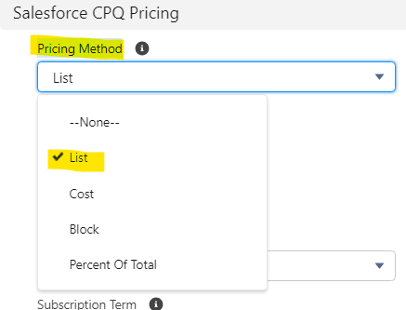](https://www.blogger.com/blog/post/edit/5479395999909322176/5600466011164237225)**

1. Save the changes
2. Go to related and click on new next to the Price Books section
3. Add a price of 600 USD and save the changes.

**2. Cost Price:**

* In CPQ, the cost price is treated as a child object of the product object and is similar to a price book entry.
* This provides the option to update the cost of a product based on business requirements. For example-when customers have raw materials like wood, metal, and gas, the pricing may often change but not the markup that reps have agreed with the customer.
* So, the cost plus markup allows an organization to control raw material pricing outside of a price book

**Steps to configure Cost Price:**

1. Navigate to the Product tab and click on New
2. Product Name- Wooden piece, check Active checkbox
3. In the Salesforce CPQ Pricing section, you will see a field Pricing Method, Select **Cost**
4. Save the changes
5. Go to related and click on new next to the Price Books section
6. Add a price of 150 USD and save the changes.
7. Click on the New button next to Costs
8. Add a cost of 100 USD and save changes

[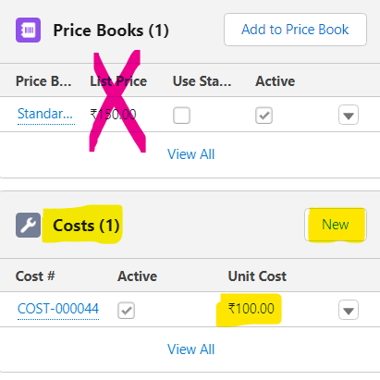](https://www.blogger.com/blog/post/edit/5479395999909322176/5600466011164237225)

1. Adding Costs record will override the standard Price book record in QLE

**Interview Questions:**

1. Explain the role of cost price in Salesforce CPQ. How do they differ from list price?
2. Can we add duplicate records for List Pirce?
3. Can we add duplicate records for Cost Price?
4. What are all type of Pricing methods in salesforce CPQ?
5. What is the need of different type of pricing methods? Can we not just tune Price book?